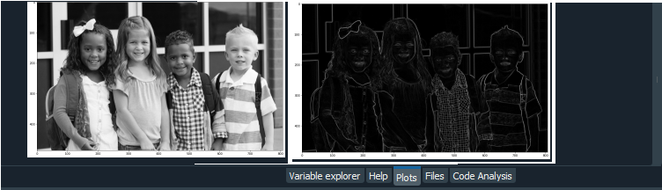

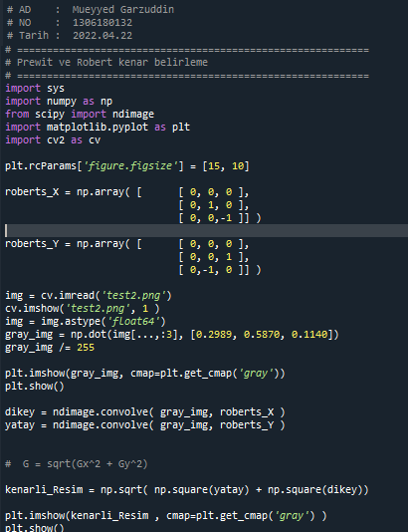

# AD : Mueyyed Garzuddin

# NO : 1306180132

# Tarih : 2022.04.22

# ===========================================================

# Robert kenar belirleme

# ===========================================================

import sys

import numpy as np

from scipy import ndimage

import matplotlib.pyplot as plt

import cv2 as cv

plt.rcParams['figure.figsize'] = [15, 10]

roberts_X = np.array( [ [ 0, 0, 0 ],

[ 0, 1, 0 ],

[ 0, 0,-1 ]] )

roberts_Y = np.array( [ [ 0, 0, 0 ],

[ 0, 0, 1 ],

[ 0,-1, 0 ]] )

img = cv.imread('test2.png')

img = img.astype('float64')

gray_img = np.dot(img[...,:3], [0.2989, 0.5870, 0.1140])

gray_img /= 255

plt.imshow(gray_img, cmap=plt.get_cmap('gray'))

plt.show()

dikey = ndimage.convolve( gray_img, roberts_X )

yatay = ndimage.convolve( gray_img, roberts_Y )

# G = sqrt(Gx^2 + Gy^2)

kenarli_Resim = np.sqrt( np.square(yatay) + np.square(dikey))

plt.imshow(kenarli_Resim , cmap=plt.get_cmap('gray') )

plt.show()